What is HashMap
HashMap is a part of the Java collection framework. It uses a technique called Hashing. It implements the map interface. It stores the data in the pair of Key and Value. HashMap contains an array of the nodes, and the node is represented as a class. It uses an array and LinkedList data structure internally for storing Key and Value. There are four fields in HashMap.
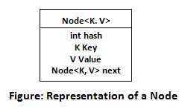
- equals(): It checks the equality of two objects. It compares the Key, whether they are equal or not. It is a method of the Object class. It can be overridden. If you override the equals() method, then it is mandatory to override the hashCode() method.
- hashCode(): This is the method of the object class. It returns the memory reference of the object in integer form. The value received from the method is used as the bucket number. The bucket number is the address of the element inside the map. Hash code of null Key is 0.
- Buckets: Array of the node is called buckets. Each node has a data structure like a LinkedList. More than one node can share the same bucket. It may be different in capacity.
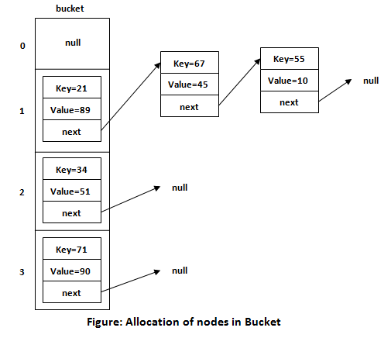

Insert Key, Value pair in HashMap
We use put() method to insert the Key and Value pair in the HashMap. The default size of HashMap is 16 (0 to 15).

Example
In the following example, we want to insert three (Key, Value) pair in the HashMap.
- HashMap<String, Integer> map = new HashMap<>();
- map.put("Aman", 19);
- map.put("Sunny", 29);
- map.put("Ritesh", 39);
Let's see at which index the Key, value pair will be saved into HashMap. When we call the put() method, then it calculates the hash code of the Key "Aman." Suppose the hash code of "Aman" is 2657860. To store the Key in memory, we have to calculate the index.

Calculating Index
Index minimizes the size of the array. The Formula for calculating the index is:
- Index = hashcode(Key) & (n-1)
Where n is the size of the array. Hence the index value for "Aman" is:
- Index = 2657860 & (16-1) = 4
The value 4 is the computed index value where the Key and value will store in HashMap.
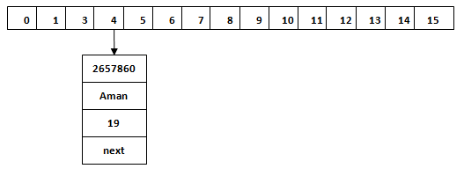

Hash Collision
This is the case when the calculated index value is the same for two or more Keys. Let's calculate the hash code for another Key "Sunny." Suppose the hash code for "Sunny" is 63281940. To store the Key in the memory, we have to calculate index by using the index formula.
- Index=63281940 & (16-1) = 4
The value 4 is the computed index value where the Key will be stored in HashMap. In this case, equals() method check that both Keys are equal or not. If Keys are same, replace the value with the current value. Otherwise, connect this node object to the existing node object through the LinkedList. Hence both Keys will be stored at index 4.
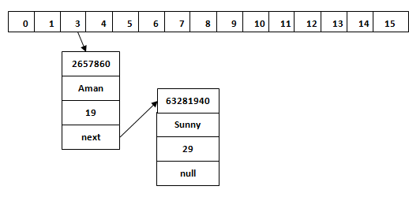
Similarly, we will store the Key "Ritesh." Suppose hash code for the Key is 2349873. The index value will be 1. Hence this Key will be stored at index 1.
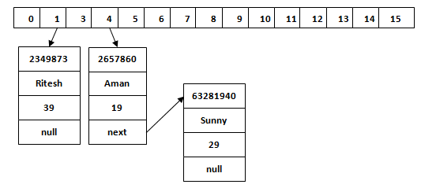

get() method in HashMap
get() method is used to get the value by its Key. It will not fetch the value if you don't know the Key. When get(K Key) method is called, it calculates the hash code of the Key.
Suppose we have to fetch the Key "Aman." The following method will be called.
- map.get(new Key("Aman"));
It generates the hash code as 2657860. Now calculate the index value of 2657860 by using index formula. The index value will be 4, as we have calculated above. get() method search for the index value 4. It compares the first element Key with the given Key. If both keys are equal, then it returns the value else check for the next element in the node if it exists. In our scenario, it is found as the first element of the node and return the value 19.
Let's fetch another Key "Sunny."
The hash code of the Key "Sunny" is 63281940. The calculated index value of 63281940 is 4, as we have calculated for put() method. Go to index 4 of the array and compare the first element's Key with the given Key. It also compares Keys. In our scenario, the given Key is the second element, and the next of the node is null. It compares the second element Key with the specified Key and returns the value 29. It returns null if the next of the node is null.

HashMap improvements in Java 8
As part of the work for JEP 180, there is a performance improvement for HashMap objects where there are lots of collisions in the keys by using balanced trees rather than linked lists to store map entries. The principal idea is that once the number of items in a hash bucket grows beyond a certain threshold, that bucket will switch from using a linked list of entries to a balanced tree. In the case of high hash collisions, this will improve worst-case performance from O(n) to O(log n).
Basically when a bucket becomes too big (currently: TREEIFY_THRESHOLD = 8), HashMap dynamically replaces it with an ad-hoc implementation of the treemap. This way rather than having pessimistic O(n) we get much better O(log n).
Binsor Buckets (elements or nodes) of TreeNodes may be traversed and used like any others, but additionally support faster lookup when overpopulated. However, since the vast majority of bins in normal use are not overpopulated, checking for the existence of tree bins may be delayed in the course of table methods.
Tree bins (i.e., bins whose elements are all TreeNodes) are ordered primarily by hashCode, but in the case of ties, if two elements are of the same “class C implements Comparable<C>“, type then their compareTo() method is used for ordering.
Because TreeNodes are about twice the size of regular nodes, we use them only when bins contain enough nodes. And when they become too small (due to removal or resizing) they are converted back to plain bins (currently: UNTREEIFY_THRESHOLD = 6). In usages with well-distributed user hashCodes, tree bins are rarely used.
So now we know how HashMap works internally in java 8.

Load Factor in HashMap
The HashMap is one of the high-performance data structure in the Java collections framework. It gives a constant time performance for insertion and retrieval. There are two factors which affect the performance of the hashmap.
- Initial Capacity
- Load Factor
We have to choose these two factors very carefully while creating the HashMap object. Load Factor and initial capacity can be configured while we create a constructor of HashMap class, as shown below:
- HashMap hm=new HashMap(int initialCapacity, float loadFactor);

Initial Capacity of HashMap
The initial capacity of the HashMap is the number of buckets in the hash table. It creates when we create the object of HashMap class. The initial capacity of the HashMap is 24, i.e., 16. The capacity of the HashMap is doubled each time it reaches the threshold. The capacity is increased to 25=32, 26=64, and so on.
Suppose we have implemented the hashCode() method, which makes sure that key-value pair will be distributed among 16 buckets equally.
Consider the following scenarios:
- If there are 16 elements in the HashMap, the hashCode() method will
- distribute one element in each bucket. The searching for any item, in this case, will take the only lookup.
- If there are 32 elements in the HashMap, the hashCode() method will distribute two elements in each bucket. The searching for any item, in this case, will take the maximum of two lookups.
- Similarly, if there are 128 elements in HashMap, the hashCode() method will distribute eight elements in each bucket. The searching for any item, in this case, will take the maximum eight lookups.
We can observe from the above scenarios that the number of items in HashMap is doubled. The maximum lookup time in each bucket is not increasing very high and remain almost constant.
Alternatively, the hashmap grows in the power of 2n and keep on growing when starting point it reached its limit.

Load Factor
The Load factor is a measure that decides when to increase the HashMap capacity to maintain the get() and put() operation complexity of O(1). The default load factor of HashMap is 0.75f (75% of the map size).
Problem
The problem is, keeping the bucket size fixed (i.e., 16), we keep on increasing the total number of items in the map that disturbs time complexity.
Solution
When we increase the total number of buckets, total items in each bucket starts increasing. Now we are able to keep the constant number of items in each bucket and maintain the time complexity of O(1) for get() and put() operation.

How Load Factor is calculated
Load Factor decides "when to increase the number of buckets."
We can find when to increase the hashmap size by using the following formula:
- initial capacity of the hashmap*Load factor of the hashmap.
The initial capacity of hashmap is=16
The default load factor of hashmap=0.75
According to the formula as mentioned above: 16*0.75=12
It represents that 12th key-value pair of hashmap will keep its size to 16. As soon as 13th element (key-value pair) will come into the Hashmap, it will increase its size from default 2⁴ = 16 buckets to 2⁵ = 32 buckets.
Another way to calculate size:
When the load factor ratio (m/n) reaches 0.75 at that time, hashmap increases its capacity.
Where,
m is the number of entries in a hashmap.
n is the total size of hashmap.

Example of Load Factor
Let's understand the load factor through an example.
We know that the default bucket size of the hashmap is 16. We insert the first element, now check that we need to increase the hashmap capacity or not. It can be determined by the formula:
- Size of hashmap (m)/number of buckets (n)
In this case, the size of the hashmap is 1, and the bucket size is 16. So, 1/16=0.0625. Now compare this value with the default load factor.
0.0625<0.75
So, no need to increase the hashmap size.
We do not need to increase the size of hashmap up to 12th element, because
12/16=0.75
This load factor is equal to the default load factor, i.e., 0.75.
As soon as we insert the 13th element in the hashmap, the size of hashmap is increased because:
13/16=0.8125
Which is greater than the default hashmap size.
0.8125>0.75
Now we need to increase the hashmap size.
If you want to keep get and put complexity O(1), it is advisable to have a load factor around 0.75.

